Muhamad Assem Ahmed
Lab 19

Part A
LAB 19 — Lab ID: 27 | MIN_GRADE_LAB = 2.5 | COURSE_COUNT = 2
Index only displays Enrollments.Count which just needs the Enrollment rows themselves loaded Details additionally prints each enrolled student's name, which is further

Part B
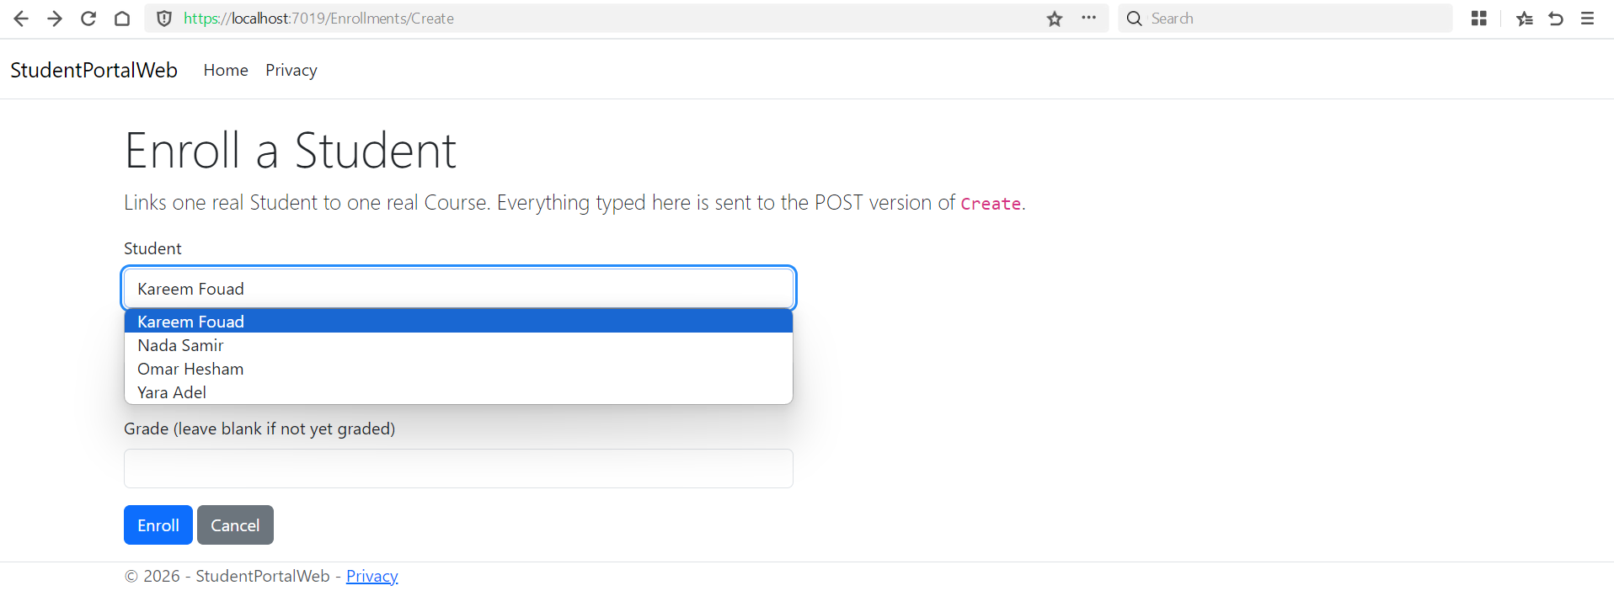
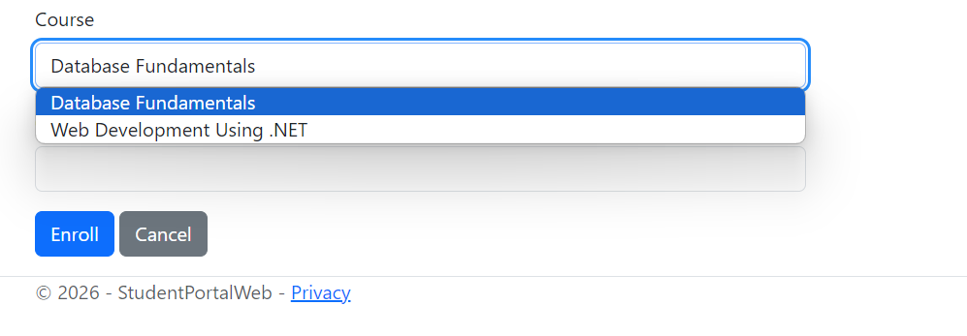

Part C

A hidden field is still client-supplied data anyone can edit the HTML or replay the request with a different value

Part D

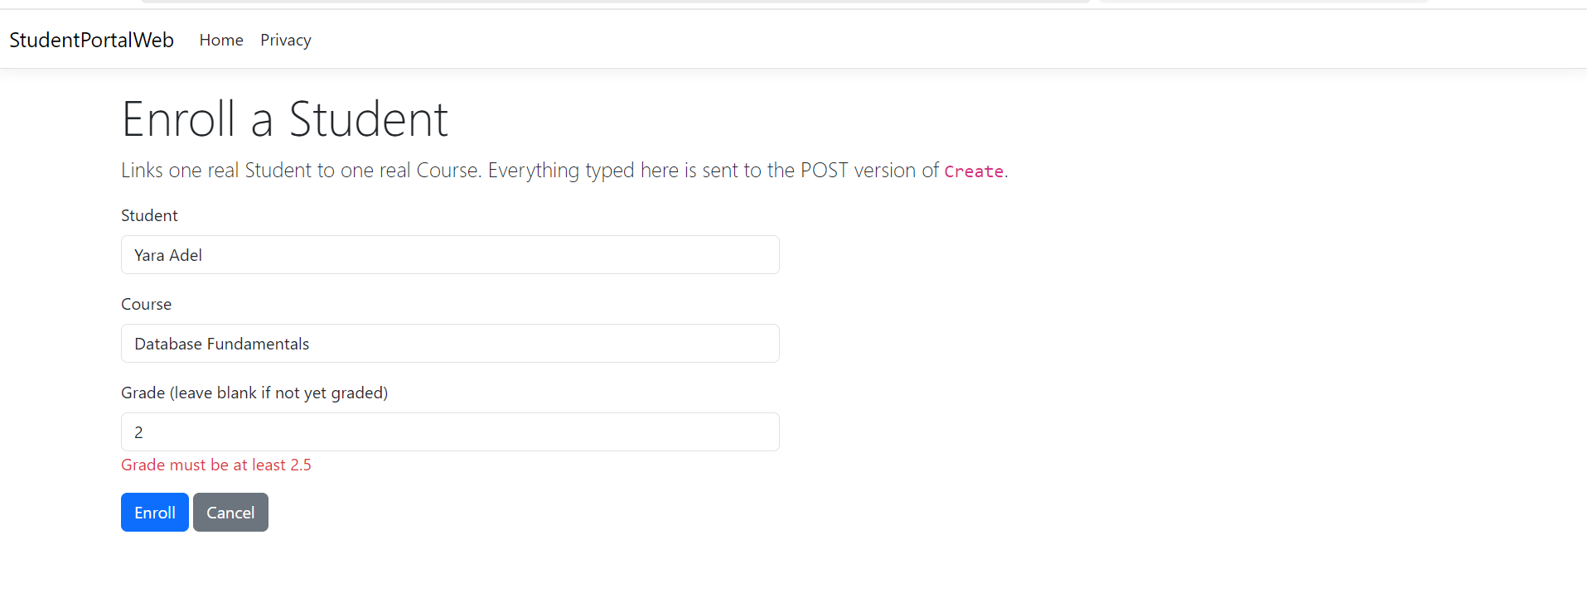
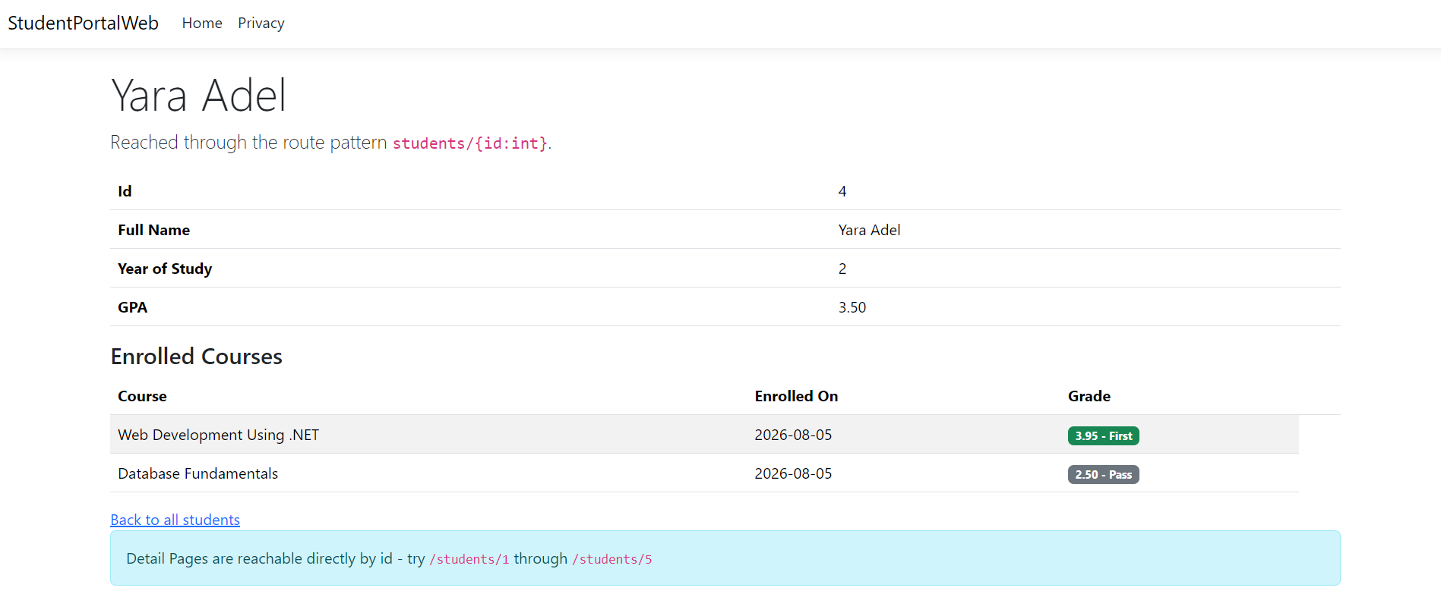
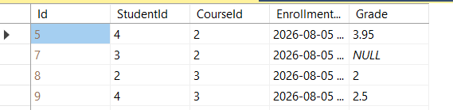

Part E

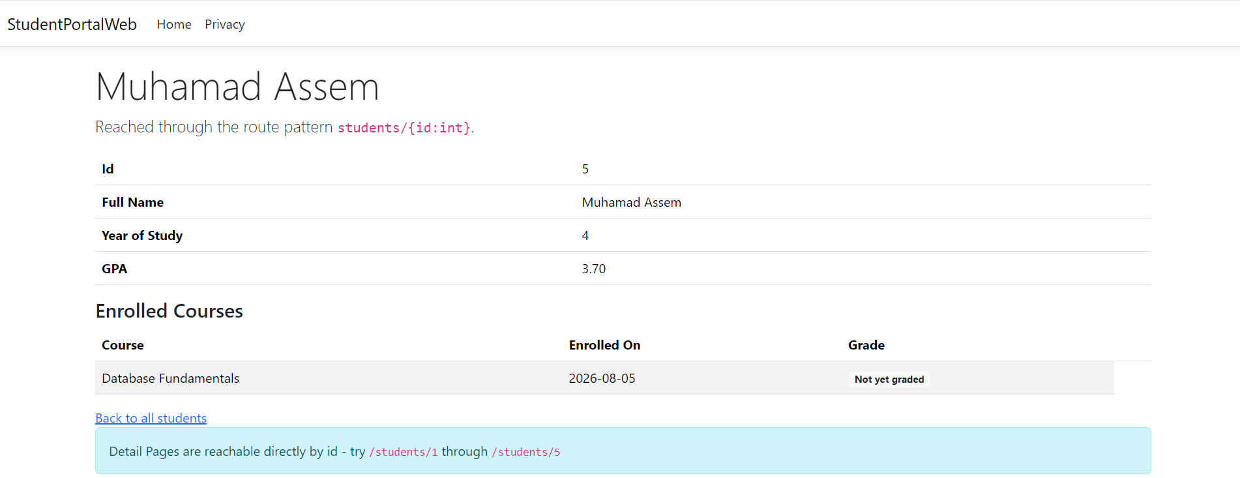

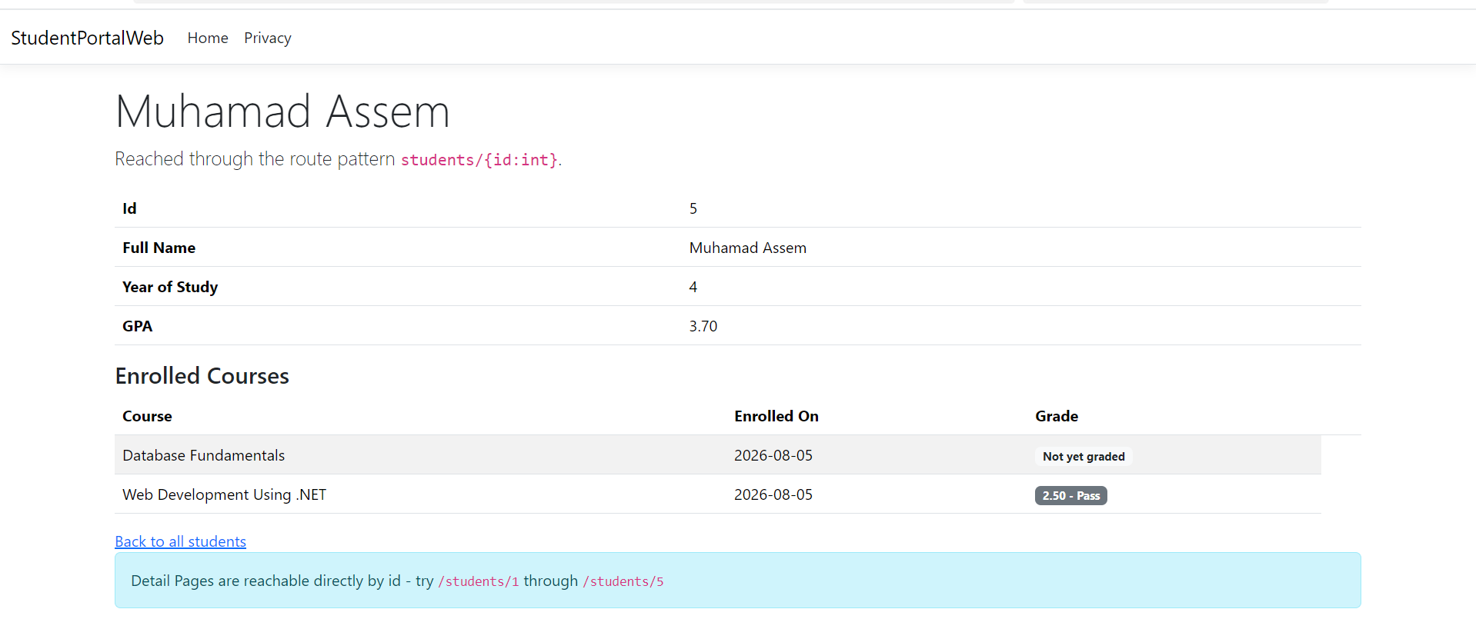


The second insert threw a DbUpdateException from SQLException

Part E

Lab ID = 27
MIN_GRADE_LAB = 1.0 + (27 mod 4) × 0.5 = 1.0 + (3 × 0.5) = 2.5
COURSE_COUNT = (27 mod 3) + 2 = 0 + 2 = 2

Enrollment data can be rejected in three places:
client-side, if the browser's own HTML5 validation catches an obviously bad value before the request is even sent
ModelState/[Range], server-side but still before the database, in the POST action's
the database itself, via constraints like the unique index

A single foreign key column can only ever point at one row, but Student and Course are each "many" to the other a student takes several courses and a course has several students. What actually fixes it is a third, associative entity

I'd choose Cascade. An Assignment has no independent meaning once its Course is deleted there's no such thing as an assignment for a course that no longer exists

